OUTPUT:
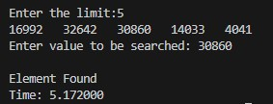

OUTPUT:
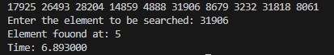

OUTPUT:
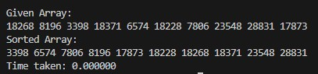

OUTPUT:
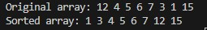

OUTPUT:
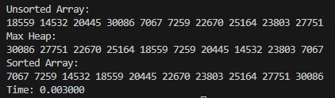

OUTPUT:
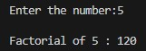

OUTPUT:
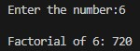

OUTPUT:
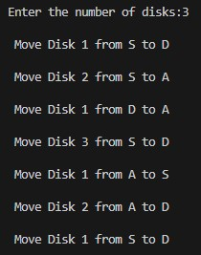

OUTPUT:
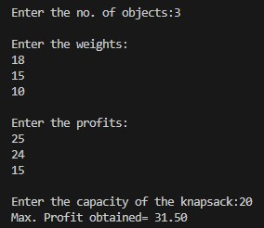

OUTPUT:
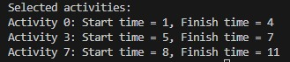

OUTPUT:
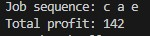

OUTPUT:
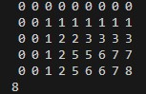

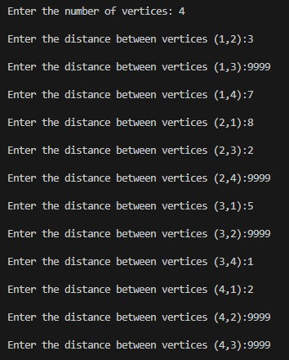
OUTPUT:

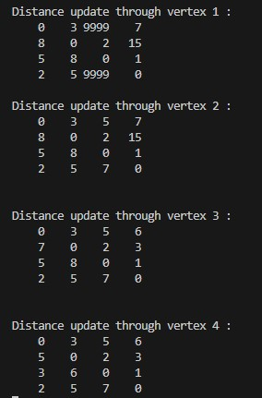

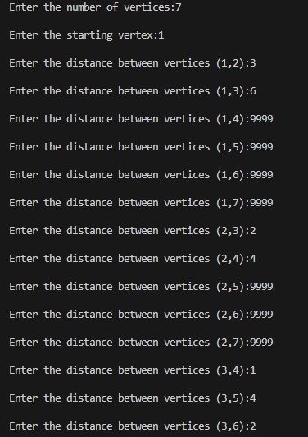
OUTPUT:

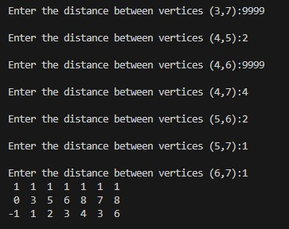

OUTPUT:
